Sample Questions - 4-H Robotics and GPS/GIS and SPIRIT Content Quiz - Pre

Name: __________________________________________________State ___________

Leader Name: ___________________________________________

Age: _________ Gender (circle one): Male Female

Multiple Choice: For each of the following questions, circle the letter of the answer that best answers the question.

- In order to follow a delayed sequence of set movements, without direct user control, a robot must be _____
  - controlled by a remote.
  - computerized.
  - programmed.
  - trained.

- A programming “loop” does which of the following?
  - Starts the program code
  - Stops the program code
  - Performs multiple functions
  - Repeats a section of program code

- A computer program consists of ______ that tells the computer to do something.
  - sensors
  - code
  - lights
  - robots

- Which of the following enables a robot to investigate and react to its environment?
  - Tires
  - Sensors
  - LCD panels
  - Mechanical arms

- What is a computer program?
  - Computer generated text
  - The hardware that controls a computer
  - Instructions written in a language a computer understands
  - Language that is built into a robot

- Which of the following is a wireless connection?
  - Bluetooth
  - RCX
  - USB
D. Serial port

- When programming your robot, a switch block or if/else/then statement is used to _____
  - ask a question.
  - stop the program.
  - speed up the program.
  - repeat the code.

- Which of the following is an example of multi-tasking?
  - Having your robot move forward on a table
  - Having your robot turn to the left for 2 seconds
  - Having your robot measure a distance as it identifies an object to lift
  - Having your robot use its light sensor

- The process of refining an instrument, like your robot, so that it is as accurate as possible by collecting information about how far your robot will travel in a given amount of time and using the information to estimate how long it will take the robot to go a given distance is called _____
  - a ratio.
  - the Pythagorean Theorem.
  - a threshold value.
  - calibration.

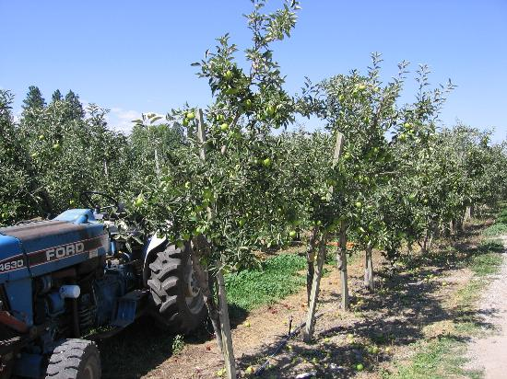
Amie and Cody are engineers working to design a robot that will be able to plant trees in a fruit production orchard with apples, apricots, oranges and/or peaches. They need your help to apply the steps of the Engineering Design Process. Answer the questions below to provide your assistance.
Image of an apple orchard from Kelowna Land and Orchard Company Ltd. (KLO) in British Columbia, Canada. Image from http://media-cdn.tripadvisor.com/media/photo-s/00/11/f9/0a/orchard-at-kelowna-land.jpg used without permission.

- Which of the following would not be part of the problem that Amie and Cody need to solve in order to begin designing their robot?
- The robot must be able to travel in standing water.
- The robot must be able to avoid obstacles such as large rocks and existing trees.
- The robot must be able to go to a specific location, using GPS.
- The robot must be able to dig a hole.
- As a part of the design process, Amie and Cody visit an engineering library to look at existing patents. Which step in the Engineering Design Process are they doing?
- Identify the problem
- Research the problem
- Select a solution
- Construct a prototype
- Amie and Cody are reviewing the possible solutions to select one to test by building a prototype. Which of the solutions below do you think is most important to the project?
- The robot should operate quietly to lessen the disturbance to wildlife in the area.
- The robot should be on tracks to cover diverse terrains.
- The robot should have a camera so the operators can see what it is doing from anywhere with an Internet connection.
- The robot should have a robotic arm that can do tasks such as dig the hole, place the tree and replace the soil.
- Which of the following strategies would be important to evaluating Amie and Cody’s solution?
- Testing the prototype by planting trees in different orchard settings or environments
- Asking other engineers on your team to review their design and prototype
- Check the design with specialized computer software to find potential flaws
- All of the above
Technology – Robotic Programming

Use the obstacle course shown to answer the robot programming questions below. The dashed line(s) shows the path of the robot. The solid line is a black electrical tape one inch wide

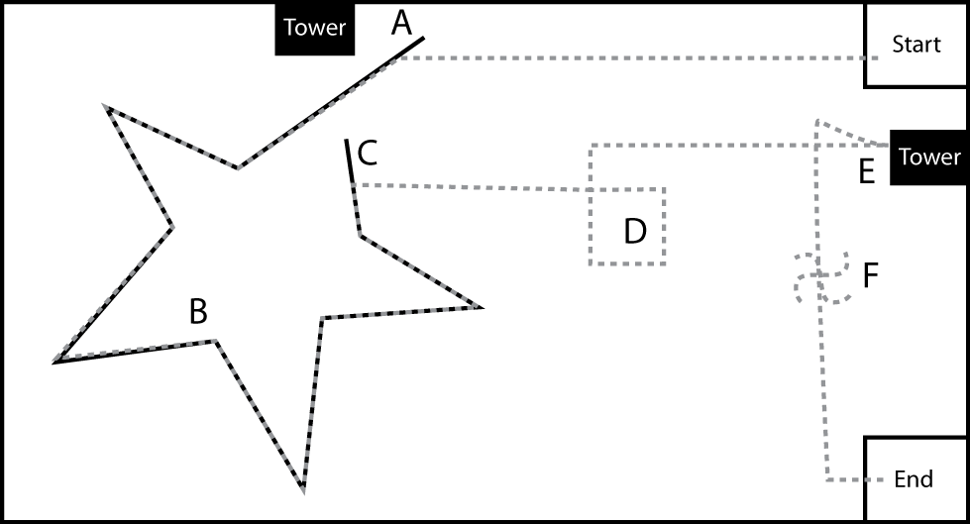

- Which sensor is most likely used to navigate the robot between points A and C?
  - Light
  - Sound
  - Touch
  - Ultrasonic
- Which of the marked points on the image above corresponds to the pseudocode shown here:
Loop 4 times – Forward one tire rotation, Turn ninety degrees right
- Point B
- Point D
- Point E
- Point F
- At point F, the robot spins counterclockwise for at least 1080 degrees. Which pseudocode line would cause the robot to turn 1080 degree?
- Forward, left motor 10 rotations
- Forward, right motor 10 rotations
- Forward turning to the left, left and right motors 10 rotations
- Forward turning to the right, left and right motors 10 rotations
- Which of the marked points in the image above corresponds to the pseudocode shown here:
Wait until touch, reverse two wheel (720 degrees) rotations
- B
- D
- E
- F
- Which of the sensors listed would most likely not be used to complete this challenge?
- Light
- Sound
- Touch
- Rotation
- Which pseudocode is the most reliable way to program the robot at point C (find the tower and then turn, using an ultrasonic sensor) in the image above?
- Forward 2.3 wheel rotations to the tower
- Forward 828 degrees to the tower
- Forward 1.6 seconds to the tower
- Forward until 15 inches from the tower

