Project SHINE / SPIRIT2.0 Lesson:
Rusted Roots
==========================Lesson Header ==========================

Lesson Title: Rusted Roots
This Teacher was mentored by:

www.behlenmfg.com

In partnership with Project SHINE grant funded through the

National Science Foundation

Draft Date: August 7, 2010
1st Author (Writer): Tracy Rumbaugh
2nd Author (Contributor): Charlie Sanders
Instructional Component Used: Problem Solving
Grade Level: 6-8 Middle

Content (what is taught):
- Problem Solving
- Communication
- Team Work

Context (how it is taught):
- Teacher presents problem example from Behlen Mfg. Co. Quality Control department
- Direct instruction of Root Cause Analysis and DMAIC (define / measure / analyze / improve / control) model with comparison to the scientific method used in classroom laboratory investigations
- Problem Solving Activity – Students will use Photo Story 3, Movie Maker, or Flip Camera software to record the process used to solve a home or school problem of their own.
Activity Description:
In this lesson, students will solve a home or school problem of their own through Root Cause Analysis and the DMAIC model used by Behlen Mfg. Co. and other business and industry leaders. The teacher will present a problem example from Behlen Mfg. Co. Quality Control Department illustrating the steps in the model used by the company to solve the problem. Students will compare and contrast RCA and the DMAIC model with the scientific method used in classroom laboratory investigations. In small groups students will brainstorm problems of inefficiency in their home and/or school. Each group will choose one focus problem to solve. Groups will apply the RCA and DMAIC models to identify a solution. Groups will use Photo Story 3, Movie Maker, or Flip Camera software to document their process and outcomes of their solution.

Standards:
Science: A1, B1, E1, F5 Technology: A3, B1, B4, D1, D3, F3

Engineering: A1, B2, E3, D1 Math: E1, E2

Materials List: (Per group of 2-4 Students)
- Rusted dog kennel photos
- Digital cameras and/or Flip cameras
- Root Cause Analysis/DMAIC PowerPoint
- Computer with Photo Story, Movie Maker or Flip Camera software
- Flowchart symbol handout
Asking Questions: (Rusted Roots)

Summary: Students will discuss the steps to solving a problem and how to use them.

Outline:
- Present the problem of the rusted dog kennels from Behlen Mfg. Co. Quality Control dept.
- Brainstorm possible causes of the problem and how to use the problem solving process.

Activity: Teacher will display photos of rusted dog kennels provided by Behlen Mfg. Co Quality Control department. Ask students “What is happening in the photos?” Ask students to identify possible causes of what they are seeing. Explain that the photos come from customers of Behlen Mfg. Co. and that this was a real problem that quality control needed to address. As students become interested throughout the demonstration ask these questions:

Questions | Answers
What is happening in the photos? | The fences are rusting.
Where are the fences rusting? | On the bottom, the fences are rusting from the bottom up.
What are possible causes of the rusting? | Moisture in the environment, rain water, dog urine, in contact with porous cement, etc.
What is the first step to problem solving? | Clear understanding of the problem/process.
What is the process of making the fence? Where did the process fail (in this case)? | Where the metal is welded it is not sealed enough for the harsh conditions/higher acidity.

Attachments:
Pictures of Dog Kennels Exhibiting Rust: S093-SHINE-Rusted_Roots-A-images.doc
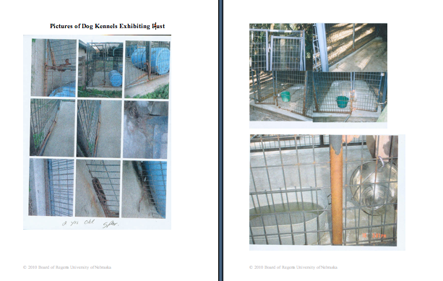

Exploring Concepts: (Rusted Roots)

Summary: Students will apply a problem solving process called Root Cause Analysis and the DMAIC model to solve the rusted dog kennel problem.

Outline:
- View PowerPoint on Root Cause Analysis and DMAIC model of problem solving
- Compare steps of the DMAIC model to the scientific method used in lab investigations
- Create a process flowchart for manufacturing a dog kennel and determine what part of the process needs to be changed to correct the problem of the rusted dog kennels

Activity: In this lesson, students will apply the process of Root Cause Analysis and the steps of the DMAIC model to the rusted dog kennel problem. Students will view the PowerPoint presentation (see attached file: S093-SHINE-Rusted_Roots-E-PowerPt.ppt) on Root Cause Analysis and the DMAIC Model that was authored by Charlie Sanders. The teacher will use a Venn diagram to lead the class in comparing the steps of the DMAIC model to the steps of the scientific method used in classroom laboratory investigations. Students will apply the steps of the DMAIC model to analyze the process and determine the root cause of the rusted dog kennel problem. The students will need the flow chart diagrams in the attached file: S093-SHINE-Rusted_Roots-E-Flowchart.doc to complete the Root Cause Analysis of the dog kennel.

Attachments:
Rusted Roots PowerPoint: S093-SHINE-Rusted_Roots-E-PowerPt.ppt (authored by Charlie Sanders)
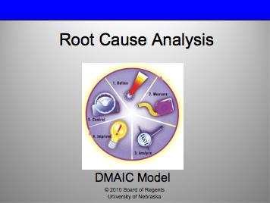

Flow Chart Diagram: S093-SHINE-Rusted_Roots-E-Flowchart.doc
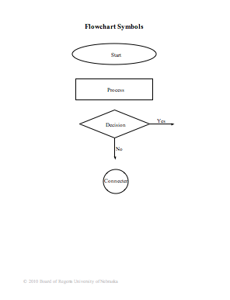

Instructing Concepts: (Rusted Roots)

Problem Solving

Problem Solving Process
The problem solving process is teachable and students will become better problem solvers with guidance and practice. Since there are many problem solving models, it depends who you talk to about which model is best. George Polya first outlined one of the best-known problem solving processes. This instructional piece will focus on Polya’s work.

Step One: Understand the Problem
This step involves the very beginning of the problem solving process. Students are asked to carefully analyze the problem paying particular attention to these questions.
• Are all the words in the problem known to you?
• What are you supposed to find, solve for, show, or prove?
• Is it possible to restate the problem in your own words?
• Is there a picture, graph or diagram that can help you understand the problem?
• Is there enough information to solve the problem?

Step Two: Devise a Plan
This step involves the process of deciding how you are going to solve the problem and creation of a plan that will lead to that solution. Below are some possible strategies that students might want to consider.
• Guess and check, look for a pattern, draw a picture, make a list
• Solve a simpler problem
• Think about problems that are similar you might have solved before
• Compare and contrast
• Use a model
• Solve an equation or work backward
This list of strategies is not all-inclusive. One of the most important strategies is to be creative and think “outside” the box to try to devise new and different ideas that may apply.

Step Three: Carry out the Plan
This step is easier than step two because you just have to stick to the plan you created. Work carefully and diligently to attempt the plan you have devised. If your plan doesn’t work go back to step two and use the knowledge you have gained to think of something else. Often we learn more from a failure than by solving a problem correctly the first time.

Step Four: Looking Back
This step is very important to becoming better problem solvers. It is this analysis of what worked and what didn’t work that lets you apply knowledge in similar situations and extend into the less familiar. You should think about where you might use the method again and think about how your strategy could be improved upon. This analysis of what happened will make problem solving easier in the future.
Organizing Learning: (Rusted Roots)

Summary: Students will investigate a problem of inefficiency at school.

Outline:
- Teacher will share extreme examples of situations where RCA may be applied
- Teacher will share examples of how everyday people have solved real problems
- Teacher will present a problem of inefficiency occurring at school
- In small groups students will discuss the problem, map out the process, and brainstorm a solution to share with the class

Activity: In this lesson, explain how Root Cause Analysis is often used in environments where there is a potential for critical consequences. Root Cause Analysis can be used in any situation where there is a gap between actual and desired outcomes. Ask what kinds of problems students normally experience in a day, who or what causes the difficulty, and are they sure this is the “true” cause (ask why five times).
Problems are often solved by everyday people wanting to better their situation or environment. Share examples of how everyday people have solved real problems (see attached file: S093-SHINE-Rusted_Roots-O-Problems.doc). After looking at each of the outside examples, ask students to look at the following school problem. In small groups, students will discuss the problem, map out the process, and brainstorm a solution to share with the class.
- At the start of each school year the lunch period runs over. New 7th grade students are inexperienced at the procedure for getting through the lunch line. What is the procedure for getting through the lunch line? What makes this process run smooth? How are the 7th graders trained in the procedure? Where is the training or the process breaking down?
- What experts could you interview about the problem (café staff, 7th grade teachers, 7th grade students)? What could we change to make the line run more efficiently earlier in the school year?

Attachments
Problem Solving Examples: S093-SHINE-Rusted_Roots-O-Problems.doc
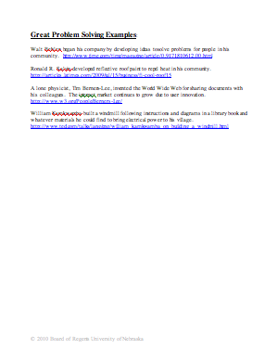

Understanding Learning: (Rusted Roots)

Summary: Students will demonstrate their ability to apply the concept of problem solving (Root Cause Analysis) and the steps of the DMAIC model to solve a home or school problem.

Outline:
- Formative assessment of problem solving
- Summative assessment of problem solving

Activity: Students will complete a Performance Assessment of problem solving (Root Cause Analysis).

Formative Assessment

As students are engaged in the lesson ask these or similar questions:

- What kinds of problems do you normally experience in a day?
- Describe a difficult problem you’ve experienced in the past? How did you solve it?
- What is a creative solution you’ve come up with to solve a previous problem?
- Do students understand the steps of problem solving/root cause analysis?

Summative Assessment (Performance Assessment)

In small groups, students will brainstorm problems of inefficiency in their home and/or school. Each group will choose one focus problem to solve. Groups will apply the RCA and DMAIC models to identify a solution. Groups will use Photo Story 3, Movie Maker, or Flip Camera software to document their process and outcomes of their solution. When completed each group will present their problem, process, and solution using the media they chose for documentation to the class. The presentation must address the following questions:

- How did the process flowchart aid in narrowing down the root cause of the problem?
- Did the action taken solve the problem? What changes occurred?
- How will you sustain the changes that occurred? Do you have future plans for monitoring the outcome?
- Is there another immediate problem that you could apply Root Cause Analysis to?
- What do you see as the benefits of Root Cause Analysis?

