SPIRIT 2.0 Lesson:

You Drive Me Crazy!

==========================Lesson Header ==========================
Lesson Title: You Drive Me Crazy
Draft Date: July 17, 2008
1st Author (Writer): Jennifer Pitzl
2nd Author (Editor/Resource Finder):
Physics Topic: Technology vs. Nontechnology with emphasis on d=s/t
Grade Level: High School
Cartoon Illustration Idea: Robotic car

Outline of Lesson

Content (what is taught):
- Application of the Physics formula d=s/t
- Measurement and creation of data tables and graphs
- Demonstration of speed and acceleration of different objects
Context (how it is taught):
- The class will complete the “walk the walk” lab with themselves and then with robot
- The speed and acceleration will be calculated on the computer using Logger Pro
- Will show limitations of technology and produce ideas how it can be improved

Activity Description:
The students will use the motion detector, logger pro software, computers, each other, and robots to analyze the motion of a student/robot moving across the room. The Students will predict, sketch, and test distance vs. time graph for both the student and the robot. Students will then analyze the difference between the two experiments and predict how to make the robots more efficient.
Standards: (At least one standard each for Math, Science, and Technology - use standards provided)

Math
A2, D1

Science
A1, A2, B1, E2

Technology
F1, A4

Materials List:
Classroom Robot Motion Detector
Data Sheet Logger Pro Software
Graph paper Vernier Lab Pro
Computer
ASKING Questions (You Drive Me Crazy)
Summary: Students are asked which would be easier to match the graphs, the classroom robot or the students themselves, and why.

Outline:
- Demonstrate the motion of the Robot
- Demonstrate the motion of a human
- Ask students about expected outcomes
- Determine variables

Activity:
Compare and contrast the ability of the robot and the student in the completion of the lab.

Questions | Possible Answers
- When the graph is moving at an increasing angle, what direction does the object need to be moving? | As the angle of the graph is increased the object will need to travel forward to match the graph.
- How can the speed be determined? | The speed can be found by taking the data and using the s=d/t formula, they can also use the graph and look at the points and calculate.
- What type of motion is occurring when the slope of a distance vs. time graph is zero? | There is no motion occurring, the object must be still.
- What are the difference between the motion of the human vs. the motion of the robot. | The motion of the robot is harder to change the speed which makes it harder if not impossible to match the graph.

Image Idea: Picture of a Robot going in a straight line with motion detector in view
Lesson Folder File:

EXPLORING Concepts (You Drive Me Crazy)
Summary: Students explore why the classroom robot struggles with matching the different graphs.

Outline:
- The robot travels forward and backwards to try to match the graph
- Students notice that the robot’s speed does not change
- The students may try different ramps to change speed of robot.

Activity:
Students will set up the lab ware according to the preliminary directions. Students will then walk forward and backwards and at different speeds to try to match the presented graph. Students will then complete analysis question.
Then working with a classroom robot, students will try to match the graphs. They may need to setup ramps to explore how the robot travels up the ramp and down different ramps. Students should notice that the speed of the robot will become less as the ramp angle is increased.
Students begin to consider the data that should be collected about the ramp and the motion of the robot. They might start measuring some of the data items such as the angle or slope of the ramp, along with the data collected with the motion detector.
To provide formative assessments as students are exploring these concepts ask yourself or your students these questions:
- How did the student’s changing of the angle of the ramp effect the speed?
- Why was the velocity vs time graph more difficult to match?

INSTRUCTING Concepts (You Drive Me Crazy)

Summary: The teacher explains the distance-time formula and how to use the motion detectors

Outline:
- Define motion in terms of velocity
- Apply the formula v = d/t

Activity:

Part I Preliminary Experiments
- Connect the Motion Detector to Dig sonic 1 of the Universal Lab Interface.
- Prepare the computer for data collection by opening “Exp 01b” from the Physics with Computers Experiment files of Logger Pro. One graph will appear on the screen. The vertical axis has distance scaled from 0 to 5 meters. The horizontal axis has time scaled from 0 to 10 seconds.
- Using Logger Pro, produce a graph of your motion when you walk away from the detector with constant velocity. To do this, stand about 1 m from the Motion Detector and have your lab partner click . Walk slowly away from the Motion Detector when you hear it begin to click.
- Try to match the shape of the distance vs. time graphs that you sketched in the Preliminary Questions section by walking in front of the Motion Detector.
Part II Distance vs. Time Graph Matching
- Prepare the computer for data collection by opening “Exp 01B” from the Physics with Computers experiment files of Logger Pro. The distance vs. time graph shown will appear.
- Describe how you would walk to produce this target graph.
- To test your prediction, choose a starting position and stand at that point. Start data collection by clicking . When you hear the Motion Detector begin to click, walk in such a way that the graph of your motion matches the target graph on the computer screen.
- If you were not successful, repeat the process until your motion closely matches the graph on the screen. If a printer is attached, print the graph with your best attempt.
- Prepare the computer for data collection by opening “Exp 01C” from the Physics with Computers experiment files of Logger Pro and repeat Steps 8 – 10, using a new target graph.
- Answer the Analysis questions for Part II before proceeding to Part III.
Part III Velocity vs. Time Graph Matching
- Prepare the computer for data collection by opening “Exp 01D” from the Physics with Computers experiment files of Logger Pro. You will see the following velocity vs. time graph.
- Describe how you would walk to produce this target graph.
- To test your prediction, choose a starting position and stand at that point. Start Logger Pro by clicking . When you hear the Motion Detector begin to click, walk in such a way that the graph of your motion matches the target graph on the screen. It will be more difficult to match the velocity graph than it was for the distance graph.
- Prepare the computer for data collection by opening “Exp 01E” from the Physics with Computers experiment files of Logger Pro. Repeat Steps 14 – 15 to match this graph.
ORGANIZING Learning (You Drive Me Crazy)
Summary: Students use data tables that record distance, time, and ramp angle, if used, to calculate the speed of themselves and their classroom robot.

Outline:
- Collect both data from the robot and themselves
- Data could includes height, distance, and time
- Calculations could include speed and acceleration
- Graph data such as speed and acceleration

Activity:
Students collect data about the motion of themselves and the classroom robot as it moves forward and backwards in site of the motion detector. Students will vary the angle of the ramp to see if there is a change in speed. Students collect data using a data table in Logger Pro or could use a spreadsheet program.
Students use the data to calculate the velocity of motion using the formula s=d/t where d is the distance, s is the speed of motion, and t is the time. They will then do an analysis of the data and predictions that could improve the motion of the robot.

Worksheet Idea: A sample data table, blank graph, and a second page of expected results
Lesson Folder File: Robot and ramp data collection.doc

 | Height of Ramp | Distance Covered | Time | Speed

Graphs that will be matched
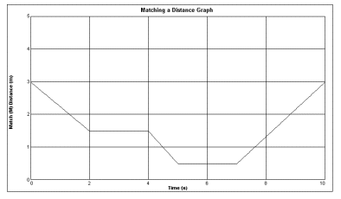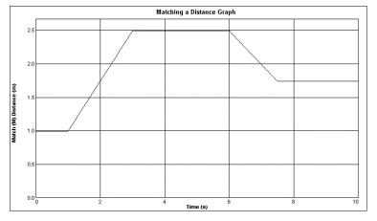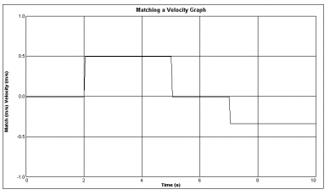

UNDERSTANDING Learning (You Drive Me Crazy)
Summary: Students will complete a lab write up about the speed formula and how to improve the robots ability to move.

Outline:
- Formative assessment of s=d/t speed
- Summative assessment of a=v/t
- Summative assessment of tables and graphs

Formative Assessment
As students are engaged in learning activities ask yourself or your students these types of questions:
1. Were the students able to apply the s=d/t formula and solve for speed?
2. Can students explain the meaning of speed?
3. Can students explain difference between speed and acceleration?

Summative Assessment
Students will complete the Analysis and lab write up that will be graded with a rubric
Part I Distance vs. Time Graph Matching (Complete Sentences)
- Describe how you walked for each of the graphs that you matched.
- Explain the significance of the slope of a distance vs. time graph. Include a discussion of positive and negative slope.
- What type of motion is occurring when the slope of a distance vs. time graph is zero?
- What type of motion is occurring when the slope of a distance vs. time graph is constant?
- What type of motion is occurring when the slope of a distance vs. time graph is changing? Test your answer to this question using the Motion Detector.
Part II Velocity vs. Time Graph Matching (Complete Sentences)
- Describe how you walked for each of the graphs that you matched.
- Using the velocity vs. time graphs, sketch the distance vs. time graph for each of the graphs that you matched. In Logger Pro, switch to a distance vs. time graph to check your answer. Do this by clicking on the y-axis label and unchecking velocity; then check Distance. Click to see the distance graph.
- What does the area under a velocity vs. time graph represent? Test your answer to this question using the Motion Detector.
- What type of motion is occurring when the slope of a velocity vs. time graph is zero?
- What type of motion is occurring when the slope of a velocity vs. time graph is not zero? Test your answer using the Motion Detector.
Part III Human vs. Robot (Short Essays)
- What was the difference in the graph matching between the robot and the human?
- What changes could be made to either the robot or the human to improve the data collection?
- Did you use any ramps to try to match the graphs with the robot? If so did it make a difference and why?

