SPIRIT 2.0 Lesson:
My Speedy Robot (Formulas, d=rt)

==========================Lesson Header ==========================
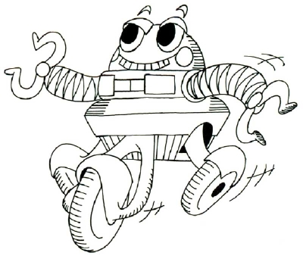
Lesson Title: My Speedy Robot
Draft Date: May 26, 2008
1st Author (Writer): Mary McAuthor
2nd Author (Editor/Resource Finder): Harry Helpful
Algebra Topic: Formulas, with a special emphasis on d=rt
Grade Level: Primary Elementary Middle Secondary
Cartoon Illustration Idea: A "huffing and puffing" robot going up a ramp

Outline of Lesson

Content (what is taught):
- Application of the mathematical formula d = rt or r = d/t
- Measurement and creation of data tables and graphs
- Demonstration of friction with different materials
Context (how it is taught):
- The classroom robot travels up a ramp set at different angles
- The distance and time are measured and recorded
- The rate of motion (speed) is calculated and the data is graphed

Activity Description:
In this lesson students investigate how the angle of a ramp impacts the classroom robot's speed up the ramp using the mathematical formula d=rt or r = d/t. Time and distance will be recorded in a chart and the rate of motion (speed) computed for each trial. Once ten trials have been completed by the students, the data results will also be graphed. For an extension, the wheels on the classroom robot could also be modified to produce additional results.

Standards: (At least one standard each for Math, Science, and Technology - use standards provided)

Math
D1, D2, E1, E3

Science
A1, A2, B1, F5

Technology
D1, D2, E2, F2

Materials List:
Classroom Robot Ramps
Stopwatch Notebook
Data Sheet Graph paper
Meter Sticks
ASKING Questions (My Speedy Robot)
Summary: Students are asked why the classroom robot is struggling to go up a ramp.

Outline:
- Demonstrate a robot climbing a ramp
- Change the ramp angle
- Ask students about expected outcomes
- Determine variables and measurements

Activity:
Demonstrate how the robot climbs a ramp. Increase the ramp angle and show how the robot begins to struggle as it climbs the ramp.

Questions | Possible Answers
- What will happen as the angle of the ramp is increased? | As the angle of the ramp is increased the robot will travel slower especially when the robot wheels begin to slip due to insufficient friction.
- How can the angle of a ramp be measured?  - What other ways can be steepness of the ramp be measured? | The angle of the ramp can be measured using a protractor but steepness can also be measured using rise and run or slope = rise / run.
- How can the motion of the robot be measured? | The motion of the robot can be measured in terms of distance and time. The formula d = rt could be used in the form r = d / t to find the rate of motion, that is the speed.
- What important pieces of data could be collected to help understand the observed motion? | By measuring distance and time, the speed of the robot could be calculated.

Image Idea: Picture of a Robot going up a ramp
Lesson Folder File: Robot and ramp.jpg

EXPLORING Concepts (My Speedy Robot)
Summary: Students explore why the classroom robot struggles to go up a ramp at various angles.

Outline:
- The robot travels up a ramp set at different angles
- Students notice the robot speed changes
- The maximum ramp angle can be found
- Changes in friction can be observed

Activity:
Working with a classroom robot, students setup ramps to explore how the robot travels up the ramp when set at different angles. Students should notice that the speed of the robot will become less as the ramp angle is increased. Students may also find there is a maximum ramp angle where the friction between the robot wheels and the ramp is not sufficient to overcome gravity and the robot wheels will begin to slip. Changing the surface of the ramp or the robot wheels may increase or decrease the friction which causes the maximum ramp angle to increase or decrease.
Students begin to consider the data that could be collected about the ramp and the motion of the robot. They might start measuring some of the data items such as the angle or slope of the ramp, and the distance and time of the motion. They can investigate how the ramp surface will affect the maximum ramp angle that the robot can successfully climb. Alternatives to ramp angle could be considered such as using rise and run to calculate the slope of the ramp. Students then discuss as a class the video clip that summarizes the robots problems at specific angles up a ramp.
To provide formative assessments as students are exploring these concepts ask yourself or your students these questions:
- Did students try to find a combination of wheels and ramp surface to provide the best performance for the robot? How successful were they at improving friction?
- How did students calculate the angle of the ramp?
- Did students try to identify the angle in which the speed of the robot dropped to zero?

Videoclip Idea: Videoclip looking at different ramp angles
Lesson Folder File: Robot ramp friction.mov
INSTRUCTING Concepts (My Speedy Robot)

Note: The instructing concepts section will be provided by the instructional writing team. The final instructing content section may look different from the one shown below. This sample is provided here so that this sample lesson shows all A, E, I, O and U components.

Summary: The teacher explains the distance-time formula and how it could be restructured to be in a form that computes the rate of motion.

Outline:
- Define motion in terms of distance
- Define rate of motion (speed)
- Apply the formula d = rt
- Derive the formula r = d / t

Activity:
We can tell a robot is moving by looking at the distance it travels. The time of travel can be measured with a stop watch. The rate of motion is related to distance and time. We would use the formula of d = rt where d is distance, r is rate of motion (speed), and t is time.

d = rt

Demonstrations of the use of this formula can help develop an understanding for the rate of motion.

For example when a distance of 6 centimeters is traveled by a robot in 3 seconds the rate of motion is 2 centimeters per second. A data table can be used to show that during each second the robot must move 2 centimeters in order to travel 6 centimeters in 3 seconds. Demonstrate other distance and time motions that result in a rate of motion that is a whole number, a fraction, and a decimal.

Once students feel comfortable with the d = rt formula, pose problems where students are to find the rate of motion. By looking at some of the previous numeric examples it can be seen that the rate of motion is found using the formula r = d / t.

r = d/t

This formula can also be derived from the d = rt formula by dividing both sides of the equation by t.

ORGANIZING Learning (My Speedy Robot)
Summary: Students use data tables that record the ramp angle, distance, time, and ramp surface to calculate the rate of motion (speed) of their classroom robot up a ramp.

Outline:
- Collect data as the robot goes up a ramp
- Vary the ramp angle and surface friction
- Data includes angle, height, distance, and time
- Calculations could include speed and slope
- Graph data such as speed verses angle

Activity:
Students collect data about the motion of a classroom robot as it struggles to go up a ramp. Students will vary the angle of the ramp and possibly the type surface of the ramp or might modify the wheels of the robot. Students collect data using a data table similar to the attached worksheet or could use a spreadsheet program. Table headings should include angle of ramp, height of ramp, distance covered, time, speed, and ramp surface. Other data items could include rise and run of the ramp, slope of the ramp, or changes made to the robot wheels.
Students use the data to calculate the rate of motion (speed) using the formula d = rt where d is the distance, r is the rate of motion, and t is the time. Students could solve the formula for r to get the formula r = d / t. Students plot graphs of the data similar to those shown on the attached worksheet. Graphs could include speed verses angle (x, y) = (angle, speed) or speed verses height. Students should find that as the angle or height of the ramp is increased the speed of the robot will be reduced. A limiting point is reached when the frictional force between the wheels and the ramp can not overcome the component of gravity pulling the robot down the ramp. Expected results are included as a second page of the attached worksheet.

Worksheet Idea: A sample data table, blank graph, and a second page of expected results
Lesson Folder File: Robot and ramp data collection.doc

Angle Of Ramp | Height of Ramp | Distance Covered | Time | Speed | Ramp Surface
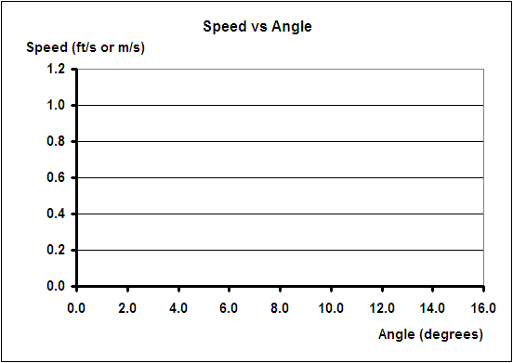

UNDERSTANDING Learning (My Speedy Robot)
Summary: Students write essays about the distance-rate-time formula and how it can be used to investigate the rate of motion (speed).

Outline:
- Formative assessment of d = rt and speed
- Summative assessment of d = rt
- Summative assessment of tables and graphs

Activity:

Formative Assessment
As students are engaged in learning activities ask yourself or your students these types of questions:
1. Were the students able to apply the d = rt formula and solve for speed?
2. Can students explain the meaning of speed?

Summative Assessment
Students will complete the following essay questions about the distance-rate-time formula:
- Write a story involving the motion of a classroom robot where the distance can be calculated using the distance-rate-time formula.
- Create a data table of the motion of a classroom robot that would show a constant rate of motion and make a graph of your data table.
- Describe how you can tell the rate of motion is constant by looking at your data table and graph.

Students could answer these quiz questions as follows:
- The classroom robot travels across the floor from Leo to Gina in 5 seconds. The robot's rate of motion (speed) across the floor is 12 centimeters per second. The distance between Leo and Gina can be found using the distance-rate-time formula: d = rt = (12 cm/s)(5 s) = 60 cm.
- The data table for the motion between Leo and Gina would be
Time (s) Distance (cm)
1 12
2 24
3 36
4 48
5 60
To graph this data table put time on the x-axis and distance on the y-axis.
- In a data table, when the distance is the same for equal time intervals the rate of motion is constant. For example the first second (0 to 1 s) the distance is 24 cm, and for the last 1 second (4 to 5 s) the distance is 60 cm - 48 cm = 12 cm. The graph of distance verses time makes a straight line when the rate of motion is constant. The rate of motion can be calculated for each row in the data table to show that the rate of motion is constant:
Time (s) Distance (cm) Rate of Motion (cm/s)
1 12 r = d / t = 12 cm / 1 s = 12 cm/s
2 24
3 36 r = d / t = 36 cm / 3 s = 12 cm/s
4 48
5 60 r = d / t = 60 cm / 5 s = 12 cm/s

