RET Lesson:
Hidden in Plain Sight
==========================Lesson Header ==========================
Lesson Title: Hidden in Plain Sight
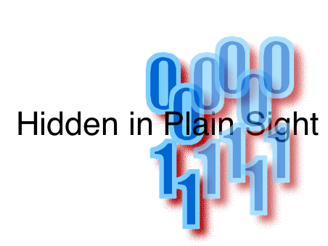
Draft Date: 7/6/12
1st Author (Writer): Derek Babb
Instructional Component Used: Steganography
Grade Level: High School

Content (what is taught):
- Steganography
- Binary Numbers
- Information Hiding

Context (how it is taught):
- History and Use of Steganography
- Creation of Steganography
- Using existing classes to modify images.
Activity Description:
The lesson will have students read about and research steganography and steganographic methods. Later, students will hide information in media using a steganographic method of their choice which will then be analyzed by their peer to see if their method was effective.

Standards:

Math: MA1 Science: SA1

Technology: TC4, TE1 Engineering: EA1

Computer Science: CT:L3:CP, CI:L3:CP

Materials List:
- Computers
Asking Questions: (Hidden in Plain Sight)

Summary: Students explore hiding information in unexpected or obscure places.

Outline:
- Read about Steganographic methods
- Discuss steganography and how society might benefit or be harmed

Activity: Students will read about steganography on the Internet to discover what it actually is. Following their initial investigations, begin a class discussion about how steganography might be used in society and whether it has positive and negative uses.

Questions | Answers
Where might we hide information online? | Images, Videos, Sound Files
What kind of information could we hide? | Text, images, other videos/sounds
How will we go undetected? | By sheer volume of data on the web, it is impractical to check every image for hidden data.
How could we begin to look for other people’s hidden data? | We need to see how hidden data affects the original file. We want to look for those changes.
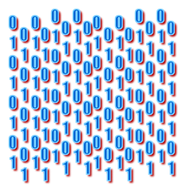
Exploring Concepts: (Hidden in Plain Sight)

Summary: Students will research steganography to learn what is it and how effectively it can be implemented.

Outline:
- Students will research techniques used in steganography
- Once students have compared the methods, they will decide how effective they are and also how difficult to implement they would be

Activity: Each student or group of students should begin to research steganography and the techniques used to encrypt data in an image or other type of file. After reading about 3-4 techniques, the students should begin to form an opinion on the effectiveness of each method. Additionally, knowing what they know about math and programming, the students should judge how difficult it would be to implement each one of these techniques.

Finally, the students should be able to determine which of these steganography techniques would be the easiest to detect, and hence the least secure.

Methods that should be included in the research are:
- Least Significant Bit modification
- Chaffing and Winnowing
- Bit-Plane Complexity Segmentation Steganography
- Transform Domain Methods
- Fourier Series – for music
Instructing Concepts: (Hidden in Plain Sight)

Steganography

Steganography is a method for concealing information within seemingly innocent media. The true craft comes from sending the information in a manner so that only the sender and the intended recipient realize its existence. Steganography may be as simple as altering the language of a message. It can also involve using a “container,” such as a jpg image, to carry a “cargo” of data, such as a text file. However the message is concealed, the art is in hiding the data in plain sight so as to hide its true intention. With steganography, seemingly unaltered images, video files, sound files, and even blank disc space can all inconspicuously carry extra data.

History of Steganography: The first recorded use of steganography dates back to the early Greeks and the ruler, Demaratus. As king of Sparta, Demaratus ruled from 515 to 491 B.C. At this time, it was common to write on waxed tablets. To communicate a warning of an impending attack on Greece by the Persian ruler Xerxes, Demaratus scraped the wax off of a wooden tablet, inscribed a message, and then covered the tablet in wax once again. In this way, the tablets carried secret information to the intended recipient without arousing suspicion. Other times of conflict are rich with examples of steganography. The Underground Railroad used quilt patterns to direct slaves on their journey northward, cryptographic writing was used numerous times in both World War I and II, and it is suspected the terrorists of 9-11 communicated through messages hidden in jpg images. Even gang graffiti can covertly pass information.

Methodology: To employ a steganographic technique, begin with a “carrier” to conceal the data. The carrier could be an image, text , or audio file. Insert the “cargo” into the carrier. The cargo is often encrypted to allow for an even greater degree of security. The finished file will be in the same format as the carrier.

Example Techniques of Steganography
Color → Letter Conversion: Colors: Every color on a computer is represented as a mixture of red, green and blue colors. Since everything is digital, at its rawest level, these colors are simply binary 0s and 1s.
Letters: Similarly to colors, every letter on the keyboard or in a message has a binary representation based on the ASCII standard. For example, the letter ‘A’ is the number 65 on the ASCII conversion chart. One easy way to hide information in an image is to simply change an entire color to the number from a single letter. For example, say you wanted to hide the message “Hello World” in an image. We could find the ASCII value of each of those letters and change the Red value of every 13th pixel to match that data. This method will leave visual artifacts of the modification.
Least Significant Bit: This method is much more difficult to detect but also more difficult to implement. In the least significant bit (LSB) method, we change rightmost bit of each color to match our data. For example in the pixel color (Red = 178, Green = 216, Blue = 222) if we switch to the binary values we get: (10110010, 11011000, 11011110). Since the letter ‘H’ is ASCII 72 is 01001000 in binary, we can begin hiding the data from this ‘H’ across the red, green and blue of many pixels in the rightmost bit by making this change: 10110010, 11011001, 11011110. The next pixel would have the right three bits values be changed to 0, 1, 0 with the remaining values of H’s ASCII in the next pixel’s right most bits. This process can be continued to hide an entire message.
Organizing Learning: (Hidden in Plain Sight)

Summary: Students will create an image with information hidden it using steganography.

Outline:
- Given the PictureEdit class and API, students can edit image data for encryption/decryption
- Do different methods make the “hidden” data easier to notice?

Activity: Students will use the PictureEdit class to open/modify/save image data and create their own methods of hiding information in an image file. They can use any method they wish to hide their info in the file but they should be able to speak to the positive/negative features of their method. When information has been hidden successfully, the final products will be exchanged and the new person will evaluate it to see how effectively the information was hidden. A class discussion will conclude the exercise to debrief the activity.

Attachments:
- T062_RET_Hidden_in_Plain_Sight_O_PictureEdit.zip
- PictureEdit.java
- Picture Edit API documentation
Understanding Learning: (Hidden in Plain Sight)

Summary: Students will write an essay about the application of steganographic techniques and the societal impact of sending secret messages without detection.

Outline:
- Formative Assessment of Steganography
- Summative Assessment of Steganography

Activity: Students will answer an essay question relating to steganography.

Formative Assessment: As students are engaged in the lesson ask these or similar
questions:
- Do students understand how steganography can be used to send secret messages?
- Can students explain whether steganography is a secure way to send information?

Summative Assessment: Students will complete the following essay questions about steganography:
- What is the basic premise of steganography and how is it used in modern society?
- In what ways is steganography a secure means of sending information and how does it fail as a secure communication method?
- What are the societal implications of modern steganography? Is it a good thing?

