Project SHINE Lesson:
Three Blind Mice
==========================Lesson Header ==========================
Lesson Title: Three Blind Mice
Draft Date: 9/6/11
1st Author (Writer): Larry St.Hilaire
Associated Business: NMC
Instructional Component Used: Shop safety
Grade Level: 10-12
This Teacher was mentored by:

In partnership with Project SHINE grant funded through the
National Science Foundation

Content (what is taught):
- Eye hazards in the shop
- PPE Safety glasses and their correct uses

Context (how it is taught):
- Recognizing eye hazards in the shop
- Correct usage of safety glasses
- Correcting dangerous situations
Activity Description:
In this lesson, students will learn the importance of a safe working environment. Through a variety of activities, students will learn to recognize and correct eye hazards, identify eye protective equipment and know their uses, and create posters or placards depicting areas of concern, hazardous tools, and eye protection usage reminders.

Standards:

Technology: TD3 Engineering: ED2

Materials List:
- Computers
- Eye Wear
- Poster Board
- Colored Pencils
- Pictures of Eye Hazards
Asking Questions: (Three Blind Mice)

Summary: Students are asked to match potential eye hazards that are in the shop with safety equipment available to them.

Outline:
- Show students hazards associated with working with tools and the handling of materials
- Describe the ways to protect themselves from hazards
- Emphasize the need for eye safety
- Give correct terminology associated with the hazards and protective equipment in the shop and welding area

Activity: The students will look at different photographs that are taken online which depict an eye safety hazard in the shop. Eye protection safety equipment will be distributed to the students. Once the students have been given the opportunity to see all the photos, they will have to create a poster with key points on eye safety in general.

Questions | Answers
What is a hazard? | Something that can harm an individual
Why is safety important? | Unsafe working conditions can potentially cause a loss of time, personal injury to yourself or others, or even death.
What are some ways you could be injured in the shop? | Burns, cuts, abrasions, loss of life or limb, loss of sight
What kinds of PPE can be used to protect you from injury? | Safety glasses, hard hat, ear plugs, gloves, aprons, masks, boots, and shields welding helmet
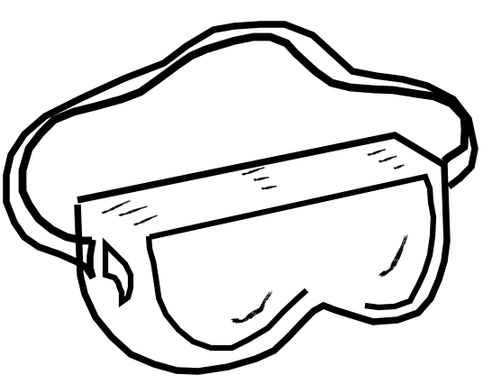
Exploring Concepts: (Three Blind Mice)

Summary: Students will find and list potential hazards in the shop.

Outline:
- Students will look at the different eye wear that NMC requires its workers to wear
- Students will learn about OSHA and the standards that they set for a safe working environment
- Students will look for potentially hazardous situations throughout the shop
- Students will list the hazards found and either find ways to correct the hazards, or list the PPE that can be used to protect themselves from harm
Activity: Students will have to create a power point slide with key points on eye safety.

Resource:
- Eye Safety PowerPoint: www.flagsafe.ufl.edu/powerpoint/eyesafety.ppt
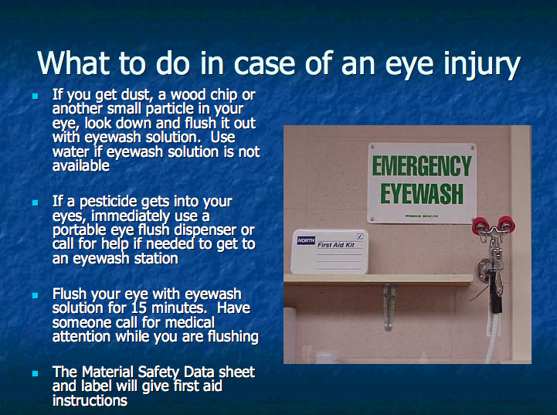
Instructing Concepts: (Three Blind Mice)

General Shop Safety

Hazards in the shop present dangers to the individual and the people working around them. A shop that is unsafe presents hazards that cause loss of time, productivity, and potentially life or limb. Whether you work in a metal, wood, automotive, glass, or electrical shop, the potential for personal injury is high. Recognizing these dangers can eliminate or reduce the likelihood of a serious injury. The following is a general list of potential hazards in a shop. The list is not likely to be a complete list of hazards.

Eye Injuries- of all types occur at the rate of about 2000/day. 10% to 20% of these injuries result in temporary or permanent vision loss. Three out of five people who receive sustainable eye injuries were not wearing eye protection.

Noise- Loud noises made by the preparation or handling of materials, machines in use, or the mix of the two can create great volumes of audible sonic vibrations that have the potential to damage the hearing of anyone within its reach. Quality earplugs or ear muffs can be used to protect you from the dangers loud noises can present.

Burns- Extreme temperatures caused by the friction of materials rubbing together, or the heating of a material, or even ultraviolet rays can present harm in the form of burns to the skin and eyes. Fire proof gloves, shaded protective eye wear, and minimizing the amount of exposed skin can greatly reduce the chances of receiving a burn.

Protruding or Ill Placed Objects- Objects that stick out into, or are lying in, a hallway can cause injury. Materials must be properly stored, or secured, so that the chances of tripping over or running into the materials are minimized.

Fire and Explosions- High volumes of dust in the air, combustible materials, or flammable gasses used or created in the shop present a threat fire and the potential for explosions. Flammable materials must be labeled with the correct placards and a MSDS sheet must be in the room to list potentially dangerous materials. Keep an open flame far away from any flammable gasses.

Moving Parts- Machines in the shop spin up to 5000 RPM. The potential for entrapment by the spinning machine parts are greatly increased when the operators are not wearing the proper clothing or do not have their hair pulled back. Loose fitting clothing, long hair not pulled back, or placing a hand in the wrong position can cause the machine to pull the protruding object into the machine resulting in injury or even death.

Toxic Fumes- Fumes in the air caused by the processes involved in working a material can present hazards to the respiratory system. These fumes enter the lungs and pose the risk of causing severe health risks. Respirators and a ventilation system will greatly reduce the chances of exposure.

High-Pressure Air and Fluid- Contents under pressure cause a potential hazard. If punctured or heated to a point of pressure too high for the container, the contents will escape at a high rate of speed. When a container under pressure is severed, the contents escape into the surrounding air seeking the low pressure presenting the risk of a fast moving object with potentially explosive or toxic gas or liquid. Containers containing a gas or fluid at high pressure must be stored vertically and proper placards must be used.
Organizing Learning: (Three Blind Mice)

Summary: Students will create posters depicting safety hazards, uses of eye wear, areas that eye wear are located, and correct eye wear required to use a machine of accomplish a task.

Outline:
- Describe to the students the importance of safety reminders throughout the shop
- Show safety posters that have been created
- List areas of the shop that require posters or placards

Activity: Students will take the information that they have been shown and create individual posters or cards depicting a specific safety hazards, uses of eye wear, areas that eye wear are located and correct eye wear required to use a machine of accomplish a task. Once completed, the students will explain what the posters depict, where it is to be located, and why there is a need to have the poster to see.

Specific Safety Hazards | Uses of Eye Wear | Areas Where Eye Wear are Located | Correct Eye Wear Required for Machines
Understanding Learning: (Three Blind Mice)

Summary: Students will recognize what eye protection to use with different materials and machines.

Outline:
- Formative assessment of shop safety
- Summative assessment of shop safety

Activity: Students will complete written and quiz based assessments on shop safety.

Formative Assessment: As students are engaged in the lesson ask these or similar questions:
- Were the students able to recognize hazards in the shop?
- Do students recognize the correct eye protection and when it is needed? Resource: www.flagsafe.ufl.edu/powerpoint/eyesafety.ppt

Summative Assessment: Students can complete the following writing prompt:
Describe a hazard in the shop. What do you need to do to protect yourself and others from this hazard?

Students will complete this short quiz using the information they have learned.
List the hazards in the following situations:
- Person standing on the top rung of a ladder.
- Cords stretching across the walkway.
- Spot for a fire extinguisher without a fire extinguisher there.
- Grinding metal without a face shield.
- Oxygen cylinder on its side.
- Person not wearing safety glasses.
- Long hair not pulled back.
- Metal bar sticking out into walkway.
- Welding with a face shield instead of a mask.
- Wearing gloves while using the grinder.

