Components for Sensor Board

There are two sensor boards. One half the components are for one and the remainder for the other.

There are components mounted on both sides of the board.

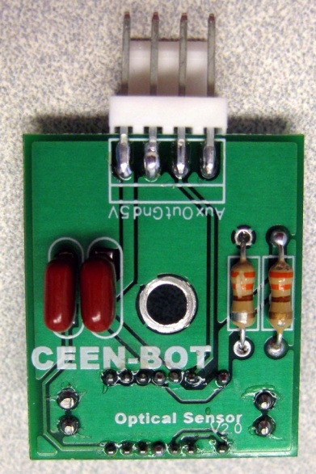
First Side
The Connector DOES NOT go into the holes on the circuit board. The leads are placed over the solder area. Melt a drop of solder on one of the pads. Position the connector and heat the lead over the drop of solder to attach the connector. When alignment is correct, solder the remaining leads.
4: R1, R2
330Ω Resistor
Orange-Orange-Brown
4: C1, C2
0.1 μF Capacitor

2: 4-Pin Connector
Pins do NOT go into the hole of the circuit board.

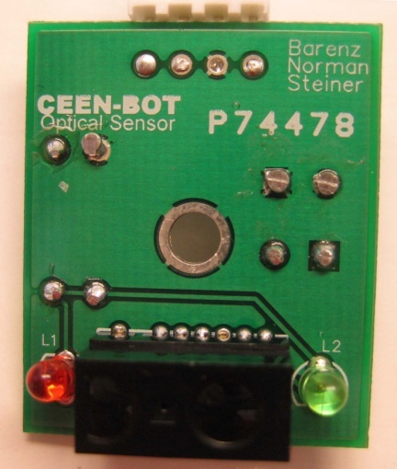
1: R5
820K ohm resistor
Gray/Red/Blk/or
3: nylon spacers
1: S1
EG1213 Switch SPDT
Dashed outlines mean component orientation is critical

Second Side

The LED colors are opposite on the two boards

The short lead of the LED is placed in the hole adjacent to the flat side of the silk screen symbol

2: Red LED
L1 on one board, L2 on the other
2: Green LED
L2 on one board, L1 on the other

2: Optical Sensor

